ACLS Rhythms Pretest Question Answers
Q1.
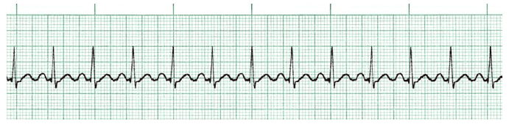
🔘 A. 3rd degree block | 🔘 D. 2nd degree I Block
🔘 B. 2nd degree II Block | 🔘 E. Sinus Tachycardia
🔘 C. Asystole | 🔘 F. Asystole
Answer

Q2.
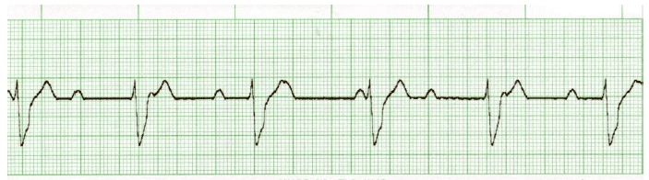
🔘 A. 3rd degree block | 🔘 D. 2nd degree I Block
🔘 B. 2nd degree II Block | 🔘 E. Fine Ventricular Fibrillation
🔘 C. Sinus Tachycardia | 🔘 F. Atrial Flutter
Answer

Q3.
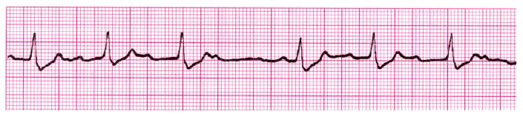
🔘 A. 3rd degree block | 🔘 D. Polymorphic VTach (Torsades)
🔘 B. 2nd degree II Block | 🔘 E. Supraventricular Tachycardia SVT
🔘 C. 2nd degree Type I Block | 🔘 F. Atrial Fibrillation
Answer

Q4.
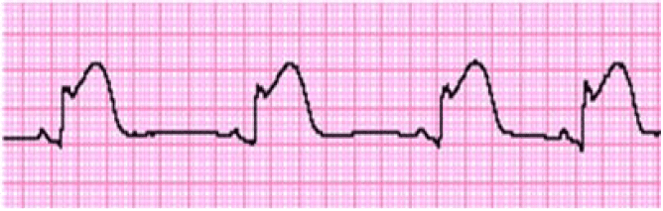
🔘 A. Atrial Flutter | 🔘 D. Atrial Fibrillation
🔘 B. Coarse VFib | 🔘 E. Supraventricular Tachycardia SVT
🔘 C. Monomorphic VTach | 🔘 F. Sinus Brady
Answer

Q5.
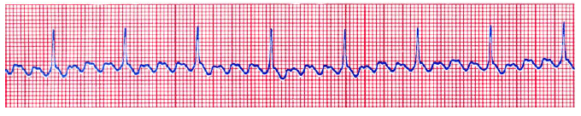
🔘 A. Atrial Flutter | 🔘 D. 2nd degree Type II Block
🔘 B. Fine Ventricular Fibrillation | 🔘 E. Fine VFib
🔘 C. Polymorphic VTach | 🔘 F. Sinus Brady
Answer
Q6.
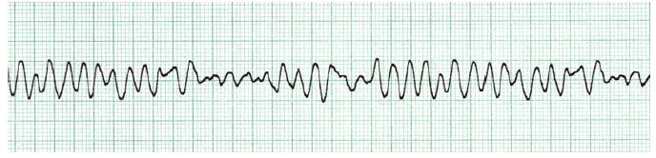
🔘 A. Atrial Flutter | 🔘 D. Atrial Fibrillation
🔘 B. Fine VFib | 🔘 E. Coarse VFib
🔘 C. Polymorphic VTach | 🔘 F. Monomorphic VTach
Answer
Q7.
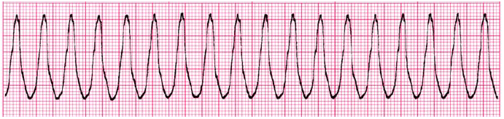
🔘 A. Normal Sinus Rhythm NSR | 🔘 D. Coarse Ventricular Fibrillation
🔘 B. Sinus Tachycardia | 🔘 E. Asystole
🔘 C. 2nd degree I Block | 🔘 F. Monomorphic VTach
Answer
Q8.
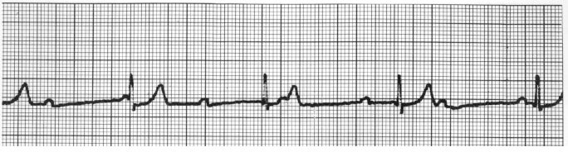
🔘 A. 2nd degree I Block | 🔘 D. 3rd degree block
🔘 B. 2nd degree II Block | 🔘 E. Sinus Tachycardia
🔘 C. Fine Ventricular Fibrillation | 🔘 F. Atrial Flutter
Answer
Q9.
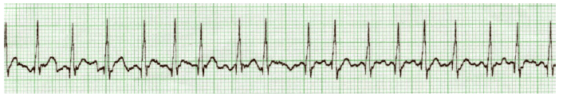
🔘 A. 3rd degree block | 🔘 D. Atrial Fibrillation
🔘 B. Asystole | 🔘 E. Atrial Flutter
🔘 C. 2nd degree Type I Block | 🔘 F. Sinus Brady
Answer
Q10.
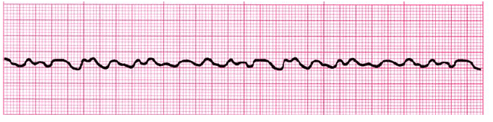
🔘 A. NSR | 🔘 D. 2nd degree Type I Block
🔘 B. SVT | 🔘 E. Fine VFib
🔘 C. Sinus Brady | 🔘 F. Monomorphic VTach
Answer

Answer Key Link:
ACLS Rhythms Practice Test: Recognition Rhythm Strips [PDF]

