WHMIS 2015 retains the use of class symbols:
Symbols | Description
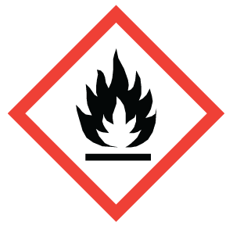 | Name: Flame  Meaning: Oxidizer  Classes and Categories  - Flammable gases (Category 1)  - Flammable aerosols (Category 1 and 2)  - Flammable liquids (Category 1, 2 and 3)  - Flammable solids (Category 1 and 2)  - Pyrophoric liquids (Category 1)  - Pyrophoric solids (Category 1)  - Pyrophoric gases (Category 1)  - Self-heating substances and mixtures (Category 1 and 2)  - Substances and mixtures which, in contact with water, emit flammable gases (Category 1, 2 and 3)  - Self-reactive substances and mixtures (Types B*, C, D, E and F)  - Organic peroxides (Types B*, C, D, E and F)
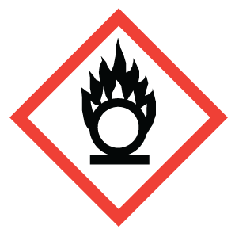 | Name: Flame Over Circle  Meaning: Flammable, Self-Reactive, Pyrophoric, Self-heating, In Contact With Water, Emits Flammable Gases, Organic Peroxide  Classes and Categories  - Oxidizing gases (Category 1)  - Oxidizing liquids (Category 1, 2 and 3)  - Oxidizing solids (Category 1, 2 and 3)
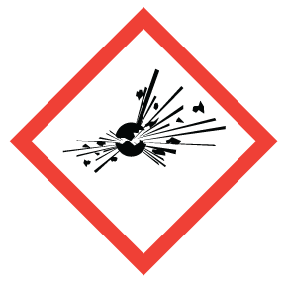 | Name: Exploding Bomb  Meaning: Explosive**, Self-Reactive (severe), Organic Peroxide (severe)  Classes and Categories  - Self-reactive substances and mixtures (Types A and B*)  - Organic peroxides (Types A and B*)
Name: Gas Cylinder
Meaning: Gas Under Pressure
Classes and Categories
- Gases under pressure (Compressed gas, Liquefied gas, Refrigerated liquefied gas, and Dissolved gas)
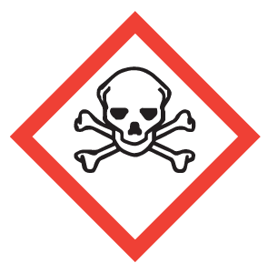 | Name: Gas Cylinder  Meaning: Acute Toxicity (fatal or toxic)  Classes and Categories  - Oral (Category 1, 2 and 3)  - Dermal (Category 1, 2 and 3)  - Inhalation (Category 1, 2 and 3)
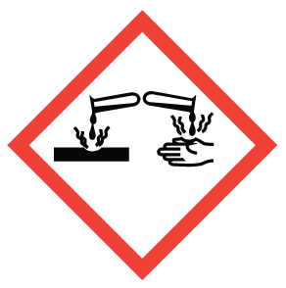 | Name: Corrosion  Meaning: Serious Eye Damage, Skin Corrosion, Corrosive to Metals  Classes and Categories  - Corrosive to metals (Category 1)  - Skin corrosion/irritation – Skin corrosion (Category 1, 1A, 1B and 1C)  - Serious eye damage/eye irritation – Serious eye damage ( Category 1)
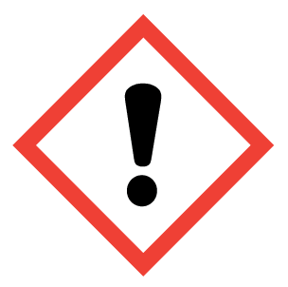 | Name: Exclamation Mark  Meaning: Irritation (skin or eyes), Skin Sensitization, Acute Toxicity (harmful), Specific Target Organ Toxicity (drowsiness or dizziness, or respiratory irritation), Hazardous to the Ozone Layer**  Classes and Categories  - Acute toxicity – Oral, Dermal, Inhalation (Category 4)  - Skin corrosion/irritation – Skin irritation (Category 2)  - Serious eye damage/eye irritation – Eye irritation (Category 2 and 2A)  - Respiratory or skin sensitization – Skin sensitizer (Category 1, 1A and 1B)  - Specific target organ toxicity – Single exposure (Category 3)
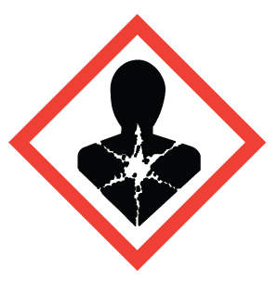 | Name: Health Hazard  Meaning: Carcinogenicity, Respiratory Sensitization, Reproductive Toxicity, Target Organ Toxicity, Germ Cell Mutagenicity, Aspiration Hazard  Classes and Categories  - Respiratory or skin sensitization – Respiratory sensitizer (Category 1, 1A and 1B)  - Germ cell mutagenicity (Category 1, 1A, 1B and 2)  - Carcinogenicity (Category 1, 1A, 1B, and 2)  - Reproductive toxicity (Category 1, 1A, 1B and 2)  - Specific Target Organ Toxicity – Single exposure (Category 1 and 2)  - Specific Target Organ Toxicity – Repeated exposure (Category 1 and 2)  - Aspiration hazard (Category 1)
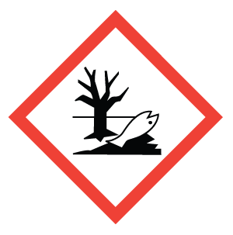 | Name: Environment  Meaning: Aquatic Toxicity**  May cause damage to the aquatic environment
Name: Biohazardous
Meaning: Biohazardous Infectious Materials
Classes and Categories
- Biohazardous Infectious Materials (Category 1)
* Both the Flame and Explosive pictogram are used for Self-reactive substances and mixtures (Type B) and Organic peroxides (Type B)
** Not required by WHMIS 2015, but may be used.

WHMIS 1988 (Old) Symbols with meaning
WHMIS 1988 retains the use of class symbols: The following table shows the pictograms. The name of each pictogram is in bold type. The words in the brackets describe the hazard.

Symbols | Hazard class | Meaning
 | CLASS A | Compressed Gas
 | CLASS B | Flammable and Combustible Material
 | CLASS C | Oxidizing Material
 | CLASS D1 | Poisonous and Infectious Material (causing immediate and serious effects)
 | CLASS D2 | Poisonous and Infectious Material  (causing other toxic effects)
 | CLASS D3 | Poisonous and Infectious Material  (Biohazardous Infectious Material)
 | CLASS E | Corrosive Material
 | CLASS F | Dangerously  Reactive Material
Reference: https://www.ccohs.ca/WHMISpictograms.html

